**Listening to cities during COVID-19 lockdown: how do human activity and urbanization impact soundscapes in Colombia?**

Juan Sebastián Ulloa*,1, Angélica Hernández-Palma1, Lina María Sánchez-Clavijo1, Orlando Acevedo-Charry1, Bibiana Gómez-Valencia1, Cristian Cruz-Rodríguez1, Yenifer Herrera1, Margarita Roa1, Susana Rodríguez-Buriticá1 , José Manuel Ochoa-Quintero1

1 Instituto de Investigación de Recursos Biológicos Alexander von Humboldt

* Corresponding author: julloa@humboldt.org.co

**Methods and Results**

### Methods

**Sampling protocol**

* Citizen science data collection using cell phones across Colombia, from 02 april to 17 july 2020.
* Participants were asked to upload audio recordings and complete an online form indicating the presence or absence of the main soundscape components: insects, amphibians, birds, mammals, rain, wind, motorized transportation, construction, loudspeakers, human voices and domestic animals.
* A total of 4556 60-second audio recordings were submitted (22050 kHz, 16 bits).
* Two periods: Full lockdown (April 02 to April 27) and Partial lockdown (May 1 to June 21).

**Data curation and preprocessing**

* We selected samples from participants that had at least 6 recordings during each period. The filtered dataset had 1909 samples from 62 participants.
* **Sound pressure level**: for each audio sample we computed the root-mean-square amplitude (RMS) as a proxy for sound pressure level (SPL). Estimates of SPL change in decibels were computed by:

$$L = 20Log10(\frac{FL}{PL})$$

Where *L* is the SPL change in decibels, *FL* is the RMS level during Full lockdown and *PL* is the RMS level measured during partial lockdown

* **Soundscape composition**: Using the online forms filled by participants, we computed an acoustic index to estimate the presence of wildlife and human sounds in the soundscape. A value of 1 indicates the presence of wildlife sounds only, and a value of 0 indicates the presence of human made sounds only . Values in between indicate a mixed presence of wildlife and human made sounds at different proportions.

**Sampling sites**

We received recordings mainly from Bogota, Medellin and Cali, the three major cities of Colombia. All other smaller cities were lumped together as “other cities” to understand the effect of urbanization on the soundscape. Table 1 summarizes the number of samples and participants from each sampling site.

**Table 1.** Summary of samples by sampling site.

|  |  |  |  |  |
| --- | --- | --- | --- | --- |
| **City** | **latitude and longitude in decimal** | | **number of samples** | **number of participants** |
| Bogotá | 4.71 | -74.07 | 711 | 21 |
| Medellín | 6.23 | -75.59 | 191 | 10 |
| Cali | 3.42 | -76.52 | 181 | 7 |
| Other cities | smaller cities with few sampling points: Pereira, Ibagué, Barranquilla, etc. | | 826 | 24 |
| **Total** | | | **1909** | **62** |

**Models**

* We used an information-theoretic framework to model sound pressure levels and soundscape composition as functions of period and city with data from the 1909 recordings and online forms.
* For the sound pressure levels, we used the root-mean-square amplitude, transformed with natural logarithm to achieve normality of residuals. For soundscape composition, we used the acoustic index mentioned above. In both cases our full model included period (full lockdown/partial lockdown) and city as fixed factors, transformed into categorical variables. We also included the participant id and the time of the day (am/pm) as random effects to control for differences among them.
* We evaluated all possible subset combinations of the variables and selected the best model using the AIC criterion corrected for small sample size (AICc), from which we estimated parameters and confidence intervals. In cases where a best model could not be identified because more than one model had sufficient support (ΔAICc 0-4), we selected all the models with ΔAICc < 4, and used a conditional model averaging procedure to calculate parameter estimates using this subset of models.
* When the period parameter was significant, we ran independent models for each city, keeping the same random structure as the previous step. This was done for both sound pressure levels and soundscape composition variables.
* Model assumptions were checked and met in all cases.

### Results

**Sound pressure level - Full model**

At a global scale, we found a significant increase of the sound pressure level, measured as rms, between the full lockdown and the partial lockdown (estimate = 0.2477, p-value<2e-16). This increase in rms is equivalent to a global increase of 2.15 dB in sound pressure level. None of the cities’ estimates were significant.

|  |  |  |  |  |  |  |  |
| --- | --- | --- | --- | --- | --- | --- | --- |
|  | **Estimate** | **Std. Error** | **Adjusted SE** | **z value** | **Pr(>|z|)** | **Confint 2.5 - 97.5%** | |
| **(Intercept)** | -5.24051 | 0.25315 | 0.25331 | 20.69 | <2e-16 | -5.737 | -4.744 |
| **P. Lockd** | 0.24765 | 0.02796 | 0.02798 | 8.85 | <2e-16 | 0.1928 | 0.3025 |
| **Cali** | 0.66932 | 0.4049 | 0.40516 | 1.65 | 0.098 | -0.1248 | 1.4634 |
| **Medellín** | 0.13003 | 0.35712 | 0.35735 | 0.36 | 0.716 | -0.5704 | 0.8304 |
| **Other** | -0.00999 | 0.27715 | 0.27733 | 0.04 | 0.971 | -0.5535 | 0.5336 |

**Bogotá**

We found a significant increase of the sound pressure level between the full lockdown and the partial lockdown (estimate = 0.3093, p-value = 6.7e-12) equivalent to a global increase of 2.69 dB in sound pressure level.

|  |  |  |  |  |  |  |  |  |
| --- | --- | --- | --- | --- | --- | --- | --- | --- |
|  | **Estimate** | **Std.Error** | **Adjusted SE** | **df** | **t value** | **Pr(>|z|)** | **Confint 2.5 - 97.5 %** | |
| **(Intercept)** | -5.3480 | 0.3035 | 0.3426 | 5.52 | -17.62 | 4.6e-06 | -5.94 | -4.75 |
| **P. Lockd** | 0.3093 | 0.0443 | 0.0823 | 689.68 | 6.99 | 6.7e-12 | 0.22 | 0.40 |

**Medellín**

We found a significant increase of the sound pressure level between the full lockdown and the partial lockdown (estimate = 0.1768, p-value = 0.032) equivalent to an increase of 1.55 dB in sound pressure level in the partial lockdown period.

|  |  |  |  |  |  |  |  |
| --- | --- | --- | --- | --- | --- | --- | --- |
|  | **Estimate** | **Std. Error** | **Adjusted SE** | **z value** | **Pr(>|z|)** | **2.50%** | **97.50%** |
| **(Intercept)** | -5.1399 | 0.3404 | 0.3426 | 15 | <2e-16 | -5.81134 | -4.4685 |
| **P. Lockd** | 0.1768 | 0.0818 | 0.0823 | 2.15 | 0.032 | 0.01544 | 0.3381 |

**Cali**

We found a significant increase of the sound pressure level between the full lockdown and the partial lockdown (estimate = 0.3036, p-value = 0.032) equivalent to a global increase of 2.64 dB in sound pressure level.

|  |  |  |  |  |  |  |  |
| --- | --- | --- | --- | --- | --- | --- | --- |
|  | **Estimate** | **Std. Error** | **df** | **t value** | **Pr(>|t|)** | **2.50%** | **97.50%** |
| **(Intercept)** | -4.6356 | 0.573 | 5.8564 | -8.09 | 0.00022 | -6.1246 | -3.144 |
| **P. Lockd** | 0.3036 | 0.0847 | 173.1794 | 3.58 | 0.00044 | 0.1366 | 0.4707 |

**Other cities**

We found a significant increase of the sound pressure level between the full lockdown and the partial lockdown (estimate = 0.199, p-value = 8.2e-06) equivalent to a global increase of 1.73 dB in sound pressure level.

|  |  |  |  |  |  |  |  |
| --- | --- | --- | --- | --- | --- | --- | --- |
|  | **Estimate** | **Std. Error** | **df** | **t value** | **Pr(>|t|)** | **2.50%** | **97.50%** |
| **(Intercept)** | -5.3054 | 0.2719 | 7.0502 | -19.51 | 2.10E-07 | -6.0216 | -4.5889 |
| **P. Lockd** | 0.199 | 0.0443 | 801.9746 | 4.49 | 8.20E-06 | 0.112 | 0.286 |

**Soundscape composition**

At a global scale, we found a significant decrease of the soundscape composition index in the partial lockdown period, indicating a progressive dominance of human made sounds over wildlife sounds as restrictions were eased. Medellin and other cities showed an increase in the index during the partial lockdown period, indicating a reverse trend compared to Bogota and Cali.

|  |  |  |  |  |  |  |  |
| --- | --- | --- | --- | --- | --- | --- | --- |
|  | **Estimate** | **Std. Error** | **df** | **t value** | **Pr(>|t|)** | **2.50%** | **97.50%** |
| **(Intercept)** | 4.40E-01 | 4.61E-02 | 3.05E+00 | 9.54 | 0.0023 | 0.29588 | 0.58391 |
| **P. Lockd** | -2.67E-02 | 5.35E-03 | 1.85E+03 | -4.99 | 6.70E-07 | -0.03717 | -0.01619 |
| **Cali** | -6.12E-03 | 4.04E-02 | 6.13E+01 | -0.15 | 0.8801 | -0.08666 | 0.07437 |
| **Medellín** | 9.02E-02 | 3.58E-02 | 6.30E+01 | 2.52 | 0.0144 | 0.01886 | 0.16154 |
| **Other** | 7.68E-02 | 2.77E-02 | 6.10E+01 | 2.78 | 0.0073 | 0.02172 | 0.13188 |

**Bogotá**

We found a significant decrease of the acoustic composition index between the full lockdown and the partial lockdown (estimate = -0.0248, p-value = 0.0018), evidencing a progressive turnover from biological to anthropogenic sounds in the city soundscape during the partial lockdown.

|  |  |  |  |  |  |  |  |
| --- | --- | --- | --- | --- | --- | --- | --- |
|  | **Estimate** | **Std. Error** | **df** | **t value** | **Pr(>|t|)** | **2.50%** | **97.50%** |
| **(Intercept)** | 0.43847 | 0.04928 | 2.68504 | 8.9 | 0.0046 | 0.28045 | 0.596425 |
| **P. Lockd** | -0.0248 | 0.00793 | 691.61891 | -3.13 | 0.0018 | -0.04036 | -0.009248 |

**Medellín**

We found a non-significant decrease of the acoustic composition index between the full lockdown and the partial lockdown (estimate = -0.0349, p-value = 0.054), evidencing a progressive turnover from biological to anthropogenic sounds in the city soundscape during the partial lockdown.

|  |  |  |  |  |  |  |  |
| --- | --- | --- | --- | --- | --- | --- | --- |
|  | **Estimate** | **Std. Error** | **Adjusted SE** | **z value** | **Pr(>|z|)** | **2.50%** | **97.50%** |
| **(Intercept)** | 0.5276 | 0.0637 | 0.0641 | 8.22 | <2e-16 | 0.40184 | 0.653285 |
| **P. Lockd** | -0.0349 | 0.018 | 0.0181 | 1.93 | 0.054 | -0.07027 | 0.000556 |

**Cali**

We found a significant decrease of the acoustic composition index between the full lockdown and the partial lockdown (estimate = -0.0481, p-value = 0.0099), evidencing a progressive turnover from biological to anthropogenic sounds in the city soundscape during the partial lockdown.

|  |  |  |  |  |  |  |  |
| --- | --- | --- | --- | --- | --- | --- | --- |
|  | **Estimate** | **Std. Error** | **df** | **t value** | **Pr(>|t|)** | **2.50%** | **97.50%** |
| **(Intercept)** | 0.4406 | 0.0714 | 3.831 | 6.17 | 0.004 | 0.23094 | 0.64945 |
| **P. Lockd** | -0.0481 | 0.0184 | 173.9951 | -2.61 | 0.0099 | -0.08439 | -0.01174 |

**Other cities**

We found a significant decrease of the acoustic composition index between the full lockdown and the partial lockdown (estimate = -0.0219, p-value = 0.00963), evidencing a progressive turnover from biological to anthropogenic sounds in the city soundscape during the partial lockdown.

|  |  |  |  |  |  |  |  |
| --- | --- | --- | --- | --- | --- | --- | --- |
|  | **Estimate** | **Std. Error** | **df** | **t value** | **Pr(>|t|)** | **2.50%** | **97.50%** |
| **(Intercept)** | 0.51498 | 0.04021 | 3.47391 | 12.81 | 0.00048 | 0.39282 | 0.637119 |
| **P. Lockd** | -0.02193 | 0.00845 | 804.27539 | -2.59 | 0.00963 | -0.03852 | -0.005347 |

## Models Details

### FULL MODEL (ALL CITIES. RMS LN TRANSFORMED)

|  |  |  |  |  |  |  |  |  |
| --- | --- | --- | --- | --- | --- | --- | --- | --- |
|  | **(Intercept)** | **muni** | **period** | **df** | **logLik** | **AICc** | **delta** | **weight** |
|  |  |  |  |  |  |  |  |  |
| **3** | -5.223 | *NA* | + | 5 | -1855 | 3721 | 0.000 | 0.8103 |
| **4** | -5.316 | + | + | 8 | -1854 | 3724 | 2.903 | 0.1897 |
| **1** | -5.106 | *NA* | *NA* | 4 | -1894 | 3795 | 74.808 | 4.615e-17 |
| **2** | -5.184 | + | *NA* | 7 | -1892 | 3798 | 77.780 | 1.044e-17 |

Call:

model.avg(object = db_dredge, subset = delta < 4)

Component model call:

lmer(formula = rms2 ~ <2 unique rhs>, data = df, REML = F)

Component models:

df logLik AICc delta weight

2 5 -1855 3721 0.0 0.81

12 8 -1854 3724 2.9 0.19

Term codes:

muni period

1 2

Model-averaged coefficients:

(full average)

Estimate Std. Error Adjusted SE z value Pr(>|z|)

(Intercept) -5.2405 0.2531 0.2533 20.69 <2e-16 ***

periodP2 0.2477 0.0280 0.0280 8.85 <2e-16 ***

muniCal 0.1270 0.3162 0.3163 0.40 0.69

muniMed 0.0247 0.1637 0.1638 0.15 0.88

muniOut -0.0019 0.1208 0.1209 0.02 0.99

(conditional average)

Estimate Std. Error Adjusted SE z value Pr(>|z|)

(Intercept) -5.24051 0.25315 0.25331 20.69 <2e-16 ***

periodP2 0.24765 0.02796 0.02798 8.85 <2e-16 ***

muniCal 0.66932 0.40490 0.40516 1.65 0.098 .

muniMed 0.13003 0.35712 0.35735 0.36 0.716

muniOut -0.00999 0.27715 0.27733 0.04 0.971

---

Signif. codes: 0 ‘***’ 0.001 ‘**’ 0.01 ‘*’ 0.05 ‘.’ 0.1 ‘ ’ 1

confint

2.5 % 97.5 %

(Intercept) -5.7370 -4.7440

periodP2 0.1928 0.3025

muniCal -0.1248 1.4634

muniMed -0.5704 0.8304

muniOut -0.5535 0.5336

|  |  |  |  |
| --- | --- | --- | --- |
|  | **rms2** | | |
| *Predictors* | *Estimates* | *CI* | *p* |
| (Intercept) | -5.32 | -5.88 – -4.75 | **<0.001** |
| period [P2] | 0.25 | 0.19 – 0.30 | **<0.001** |
| muni [Cal] | 0.67 | -0.12 – 1.46 | 0.098 |
| muni [Med] | 0.13 | -0.57 – 0.83 | 0.716 |
| muni [Out] | -0.01 | -0.55 – 0.53 | 0.971 |
| **Random Effects** | | | |
| σ2 | 0.36 | | |
| τ00 email | 0.85 | | |
| τ00 am_pm | 0.09 | | |
| ICC | 0.72 | | |
| N am_pm | 2 | | |
| N email | 62 | | |
| Observations | 1909 | | |
| Marginal R2 / Conditional R2 | 0.040 / 0.735 | | |

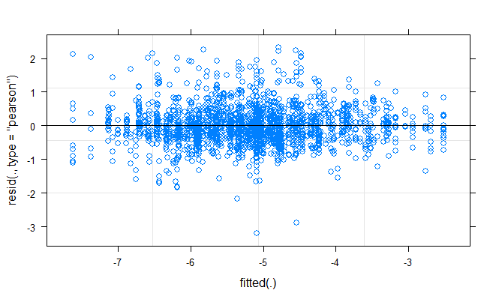

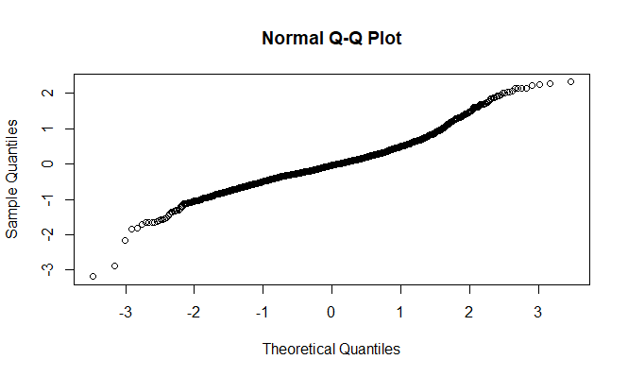

### MODEL FOR BOGOTA (RMS LN TRANSFORMED)

|  |  |  |  |  |  |  |  |
| --- | --- | --- | --- | --- | --- | --- | --- |
|  | **(Intercept)** | **period** | **Df** | **logLik** | **AICc** | **delta** | **weight** |
|  |  |  |  |  |  |  |  |
| **2** | -5.348 | + | 5 | -667.4 | 1345 | 0.00 | 1.000e+00 |
| **1** | -5.183 | *NA* | 4 | -691.0 | 1390 | 45.14 | 1.574e-1 |

Linear mixed model fit by maximum likelihood . t-tests use Satterthwaite's method ['lmerModLmerTest']

Formula: rms2 ~ period + (1 | am_pm) + (1 | email)

Data: bog

AIC BIC logLik deviance df.resid

1344.7 1367.6 -667.4 1334.7 706

Scaled residuals:

Min 1Q Median 3Q Max

-2.812 -0.582 -0.099 0.503 3.760

Random effects:

Groups Name Variance Std.Dev.

email (Intercept) 0.859 0.927

am_pm (Intercept) 0.100 0.317

Residual 0.334 0.578

Number of obs: 711, groups: email, 21; am_pm, 2

Fixed effects:

Estimate Std. Error df t value Pr(>|t|)

(Intercept) -5.3480 0.3035 5.5249 -17.62 4.6e-06 ***

periodP2 0.3093 0.0443 689.6791 6.99 6.7e-12 ***

---

Signif. codes: 0 ‘***’ 0.001 ‘**’ 0.01 ‘*’ 0.05 ‘.’ 0.1 ‘ ’ 1

Correlation of Fixed Effects:

(Intr)

periodP2 -0.078

|  |  |  |  |
| --- | --- | --- | --- |
|  | **rms2** | | |
| *Predictors* | *Estimates* | *CI* | *p* |
| (Intercept) | -5.35 | -5.94 – -4.75 | **<0.001** |
| period [P2] | 0.31 | 0.22 – 0.40 | **<0.001** |
| **Random Effects** | | | |
| σ2 | 0.33 | | |
| τ00 email | 0.86 | | |
| τ00 am_pm | 0.10 | | |
| ICC | 0.74 | | |
| N am_pm | 2 | | |
| N email | 21 | | |
| Observations | 711 | | |
| Marginal R2 / Conditional R2 | 0.018 / 0.746 | | |

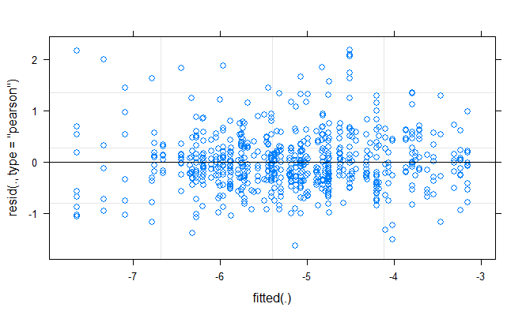

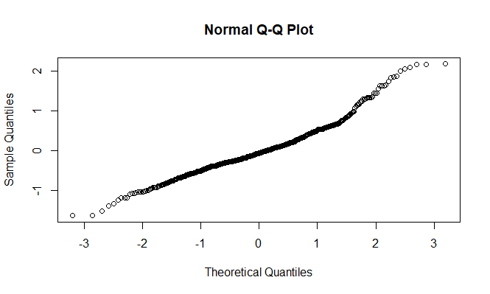

### MODEL FOR MEDELLIN (RMS LN TRANSFORMED)

|  |  |  |  |  |  |  |  |
| --- | --- | --- | --- | --- | --- | --- | --- |
|  | **(Intercept)** | **period** | **df** | **logLik** | **AICc** | **delta** | **weight** |
|  |  |  |  |  |  |  |  |
| **2** | -5.155 | + | 5 | -174.1 | 358.5 | 0.000 | 0.7777 |
| **1** | -5.088 | *NA* | 4 | -176.4 | 361.0 | 2.505 | 0.2223 |

Call:

model.avg(object = db_med_dredge, subset = delta < 4)

Component model call:

lmer(formula = rms2 ~ <2 unique rhs>, data = med, REML = F)

Component models:

df logLik AICc delta weight

1 5 -174.1 358.5 0.0 0.78

(Null) 4 -176.4 361.0 2.5 0.22

Term codes:

period

1

Model-averaged coefficients:

(full average)

Estimate Std. Error Adjusted SE z value Pr(>|z|)

(Intercept) -5.140 0.340 0.343 15.00 <2e-16 ***

periodP2 0.137 0.103 0.103 1.33 0.18

(conditional average)

Estimate Std. Error Adjusted SE z value Pr(>|z|)

(Intercept) -5.1399 0.3404 0.3426 15.00 <2e-16 ***

periodP2 0.1768 0.0818 0.0823 2.15 0.032 *

---

Signif. codes: 0 ‘***’ 0.001 ‘**’ 0.01 ‘*’ 0.05 ‘.’ 0.1 ‘ ’ 1

Confidence intervals

2.5 % 97.5 %

(Intercept) -5.81134 -4.4685

periodP2 0.01544 0.3381

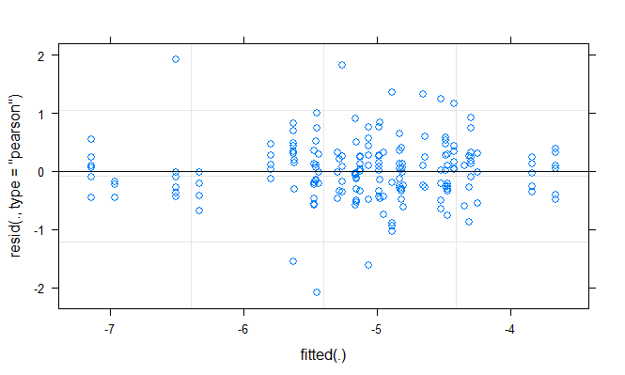

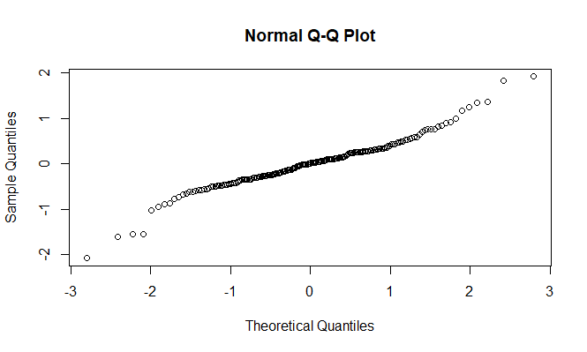

|  |  |  |  |
| --- | --- | --- | --- |
|  | **rms2** | | |
| *Predictors* | *Estimates* | *CI* | *p* |
| (Intercept) | -5.15 | -5.82 – -4.49 | **<0.001** |
| period [P2] | 0.18 | 0.02 – 0.34 | **0.031** |
| **Random Effects** | | | |
| σ2 | 0.30 | | |
| τ00 email | 0.47 | | |
| τ00 am_pm | 0.13 | | |
| ICC | 0.67 | | |
| N am_pm | 2 | | |
| N email | 10 | | |
| Observations | 191 | | |
| Marginal R2 / Conditional R2 | 0.008 / 0.674 | | |

### MODEL FOR CALI (RMS LN TRANSFORMED)

|  |  |  |  |  |  |  |  |
| --- | --- | --- | --- | --- | --- | --- | --- |
|  | **(Intercept)** | **period** | **df** | **logLik** | **AICc** | **delta** | **weight** |
|  |  |  |  |  |  |  |  |
| **2** | -4.636 | + | 5 | -166.8 | 344.0 | 0.00 | 0.994152 |
| **1** | -4.490 | *NA* | 4 | -173.0 | 354.2 | 10.27 | 0.005848 |

Linear mixed model fit by maximum likelihood . t-tests use Satterthwaite's method ['lmerModLmerTest']

Formula: rms2 ~ period + (1 | am_pm) + (1 | email)

Data: clo

AIC BIC logLik deviance df.resid

343.6 359.6 -166.8 333.6 176

Scaled residuals:

Min 1Q Median 3Q Max

-2.414 -0.595 -0.089 0.449 3.775

Random effects:

Groups Name Variance Std.Dev.

email (Intercept) 1.298 1.139

am_pm (Intercept) 0.279 0.528

Residual 0.300 0.548

Number of obs: 181, groups: email, 7; am_pm, 2

Fixed effects:

Estimate Std. Error df t value Pr(>|t|)

(Intercept) -4.6356 0.5730 5.8564 -8.09 0.00022 ***

periodP2 0.3036 0.0847 173.1794 3.58 0.00044 ***

---

Signif. codes: 0 ‘***’ 0.001 ‘**’ 0.01 ‘*’ 0.05 ‘.’ 0.1 ‘ ’ 1

Correlation of Fixed Effects:

(Intr)

periodP2 -0.071

Confidence intervals

2.5 % 97.5 %

.sig01 0.7176 2.1733

.sig02 0.2264 2.3815

.sigma 0.4948 0.6111

(Intercept) -6.1246 -3.1440

periodP2 0.1366 0.4707

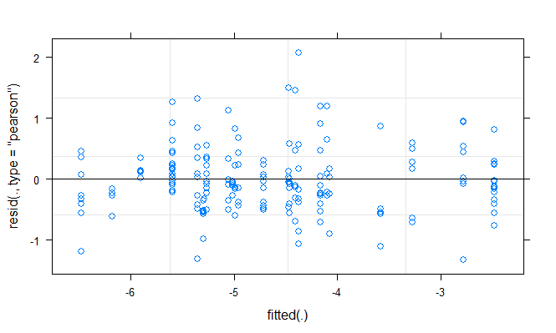

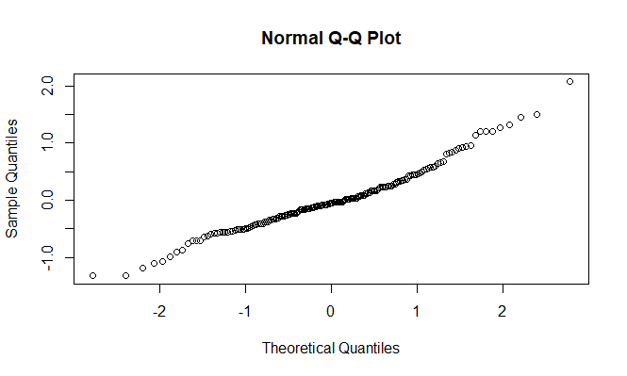

|  |  |  |  |
| --- | --- | --- | --- |
|  | **rms2** | | |
| *Predictors* | *Estimates* | *CI* | *p* |
| (Intercept) | -4.64 | -5.76 – -3.51 | **<0.001** |
| period [P2] | 0.30 | 0.14 – 0.47 | **<0.001** |
| **Random Effects** | | | |
| σ2 | 0.30 | | |
| τ00 email | 1.30 | | |
| τ00 am_pm | 0.28 | | |
| ICC | 0.84 | | |
| N am_pm | 2 | | |
| N email | 7 | | |
| Observations | 181 | | |
| Marginal R2 / Conditional R2 | 0.012 / 0.842 | | |

### MODEL FOR OTHER CITIES (RMS LN TRANSFORMED)

|  |  |  |  |  |  |  |  |
| --- | --- | --- | --- | --- | --- | --- | --- |
|  | **(Intercept)** | **period** | **df** | **logLik** | **AICc** | **delta** | **weight** |
|  |  |  |  |  |  |  |  |
| **2** | -5.305 | + | 5 | -835.8 | 1682 | 0.00 | 0.9998685 |
| **1** | -5.215 | *NA* | 4 | -845.7 | 1699 | 17.87 | 0.0001315 |

Linear mixed model fit by maximum likelihood . t-tests use Satterthwaite's method ['lmerModLmerTest']

Formula: rms2 ~ period + (1 | am_pm) + (1 | email)

Data: other

AIC BIC logLik deviance df.resid

1681.5 1705.1 -835.8 1671.5 821

Scaled residuals:

Min 1Q Median 3Q Max

-5.140 -0.547 -0.074 0.445 3.756

Random effects:

Groups Name Variance Std.Dev.

email (Intercept) 0.933 0.966

am_pm (Intercept) 0.068 0.261

Residual 0.389 0.624

Number of obs: 826, groups: email, 24; am_pm, 2

Fixed effects:

Estimate Std. Error df t value Pr(>|t|)

(Intercept) -5.3054 0.2719 7.0502 -19.51 2.1e-07 ***

periodP2 0.1990 0.0443 801.9746 4.49 8.2e-06 ***

---

Signif. codes: 0 ‘***’ 0.001 ‘**’ 0.01 ‘*’ 0.05 ‘.’ 0.1 ‘ ’ 1

Correlation of Fixed Effects:

(Intr)

periodP2 -0.074

confidence intervals

2.5 % 97.5 %

.sig01 0.7407 1.3270

.sig02 0.1128 1.1593

.sigma 0.5947 0.6559

(Intercept) -6.0216 -4.5889

periodP2 0.1120 0.2860

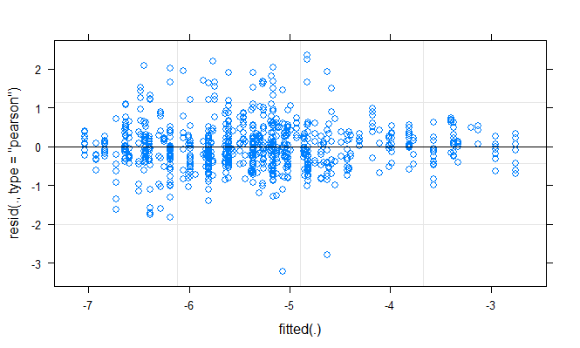

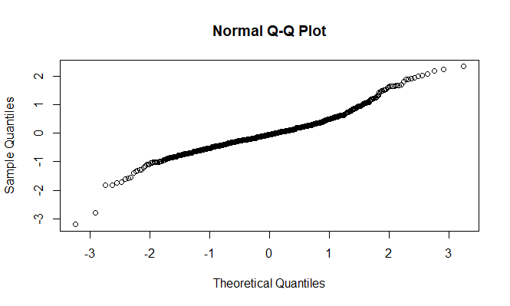

|  |  |  |  |
| --- | --- | --- | --- |
|  | **rms2** | | |
| *Predictors* | *Estimates* | *CI* | *p* |
| (Intercept) | -5.31 | -5.84 – -4.77 | **<0.001** |
| period [P2] | 0.20 | 0.11 – 0.29 | **<0.001** |
| **Random Effects** | | | |
| σ2 | 0.39 | | |
| τ00 email | 0.93 | | |
| τ00 am_pm | 0.07 | | |
| ICC | 0.72 | | |
| N am_pm | 2 | | |
| N email | 24 | | |
| Observations | 826 | | |
| Marginal R2 / Conditional R2 | 0.007 / 0.722 | | |

### SOUNDSCAPE COMPONENTS INDEX FOR ALL CITIES - DURING AND POST LOCKDOWN

**ALL CITIES**

|  |  |  |  |  |  |  |  |  |
| --- | --- | --- | --- | --- | --- | --- | --- | --- |
|  | **(Intercept)** | **muni** | **period** | **df** | **logLik** | **AICc** | **delta** | **weight** |
|  |  |  |  |  |  |  |  |  |
| **4** | 0.4399 | + | + | 8 | 1342 | -2668 | 0.000 | 9.281e-01 |
| **3** | 0.4834 | *NA* | + | 5 | 1336 | -2663 | 5.117 | 7.186e-02 |
| **2** | 0.4257 | + | *NA* | 7 | 1330 | -2645 | 22.697 | 1.094e-05 |
| **1** | 0.4707 | *NA* | *NA* | 4 | 1324 | -2639 | 28.300 | 6.642e-07 |

Linear mixed model fit by maximum likelihood . t-tests use Satterthwaite's method ['lmerModLmerTest']

Formula: mix_idx ~ period + muni + (1 | am_pm) + (1 | email)

Data: df

AIC BIC logLik deviance df.resid

-2668 -2623 1342 -2684 1901

Scaled residuals:

Min 1Q Median 3Q Max

-3.146 -0.699 0.023 0.709 3.175

Random effects:

Groups Name Variance Std.Dev.

email (Intercept) 0.00808 0.0899

am_pm (Intercept) 0.00342 0.0585

Residual 0.01302 0.1141

Number of obs: 1909, groups: email, 62; am_pm, 2

Fixed effects:

Estimate Std. Error df t value Pr(>|t|)

(Intercept) 4.40e-01 4.61e-02 3.05e+00 9.54 0.0023 **

periodP2 -2.67e-02 5.35e-03 1.85e+03 -4.99 6.7e-07 ***

muniCal -6.12e-03 4.04e-02 6.13e+01 -0.15 0.8801

muniMed 9.02e-02 3.58e-02 6.30e+01 2.52 0.0144 *

muniOut 7.68e-02 2.77e-02 6.10e+01 2.78 0.0073 **

---

Signif. codes: 0 ‘***’ 0.001 ‘**’ 0.01 ‘*’ 0.05 ‘.’ 0.1 ‘ ’ 1

Correlation of Fixed Effects:

(Intr) perdP2 muniCl muniMd

periodP2 -0.062

muniCal -0.218 0.007

muniMed -0.247 0.023 0.281

muniOut -0.320 0.015 0.364 0.411

confidence intervals

2.5 % 97.5 %

.sig01 0.07511 0.10956

.sig02 0.02762 0.24547

.sigma 0.11052 0.11789

(Intercept) 0.29588 0.58391

periodP2 -0.03717 -0.01619

muniCal -0.08666 0.07437

muniMed 0.01886 0.16154

muniOut 0.02172 0.13188

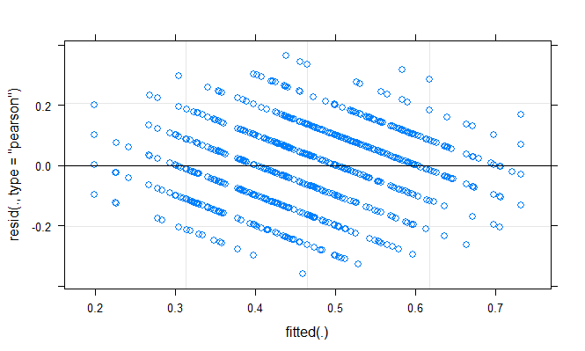

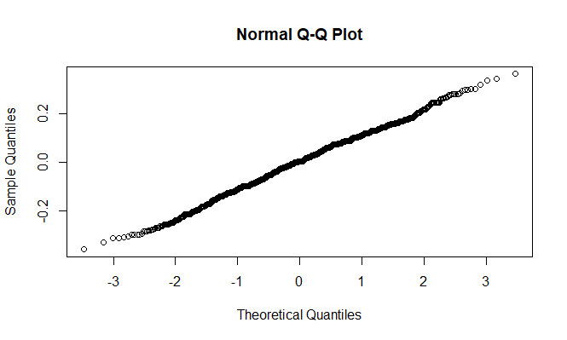

**BOGOTA ONLY**

|  |  |  |  |  |  |  |  |
| --- | --- | --- | --- | --- | --- | --- | --- |
|  | **(Intercept)** | **period** | **df** | **logLik** | **AICc** | **delta** | **weight** |
|  |  |  |  |  |  |  |  |
| **2** | 0.4385 | + | 5 | 568.9 | -1128 | 0.000 | 0.97914 |
| **1** | 0.4253 | *NA* | 4 | 564.0 | -1120 | 7.698 | 0.02086 |

Linear mixed model fit by maximum likelihood . t-tests use Satterthwaite's method ['lmerModLmerTest']

Formula: mix_idx ~ period + (1 | am_pm) + (1 | email)

Data: bog

AIC BIC logLik deviance df.resid

-1127.8 -1105.0 568.9 -1137.8 706

Scaled residuals:

Min 1Q Median 3Q Max

-2.9579 -0.7199 -0.0021 0.7757 2.5692

Random effects:

Groups Name Variance Std.Dev.

email (Intercept) 0.00688 0.0829

am_pm (Intercept) 0.00413 0.0643

Residual 0.01070 0.1035

Number of obs: 711, groups: email, 21; am_pm, 2

Fixed effects:

Estimate Std. Error df t value Pr(>|t|)

(Intercept) 0.43847 0.04928 2.68504 8.90 0.0046 **

periodP2 -0.02480 0.00793 691.61891 -3.13 0.0018 **

---

Signif. codes: 0 ‘***’ 0.001 ‘**’ 0.01 ‘*’ 0.05 ‘.’ 0.1 ‘ ’ 1

Correlation of Fixed Effects:

(Intr)

periodP2 -0.086

confidence intervals

2.5 % 97.5 %

.sig01 0.06154 0.118223

.sig02 0.03003 0.270690

.sigma 0.09823 0.109173

(Intercept) 0.28045 0.596425

periodP2 -0.04036 -0.009248

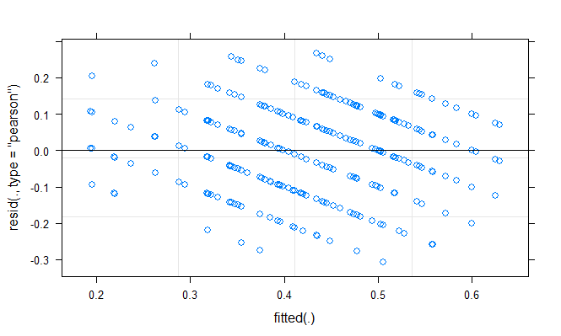

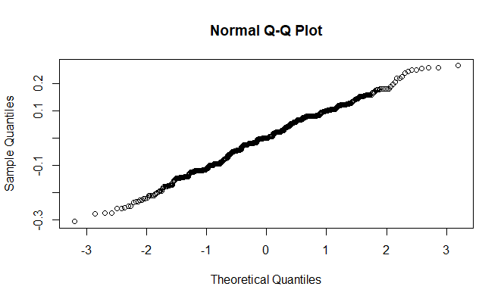

**MEDELLIN ONLY**

|  |  |  |  |  |  |  |  |
| --- | --- | --- | --- | --- | --- | --- | --- |
|  | **(Intercept)** | **period** | **df** | **logLik** | **AICc** | **delta** | **weight** |
|  |  |  |  |  |  |  |  |
| **2** | 0.5316 | + | 5 | 120.6 | -230.8 | 0.000 | 0.6925 |
| **1** | 0.5185 | *NA* | 4 | 118.7 | -229.2 | 1.624 | 0.3075 |

model.avg(object = indx_med_dredge, subset = delta < 4)

Component model call:

lmer(formula = mix_idx ~ <2 unique rhs>, data = med, REML = F)

Component models:

df logLik AICc delta weight

1 5 120.6 -230.8 0.00 0.69

(Null) 4 118.7 -229.2 1.62 0.31

Term codes:

period

1

Model-averaged coefficients:

(full average)

Estimate Std. Error Adjusted SE z value Pr(>|z|)

(Intercept) 0.5276 0.0637 0.0641 8.22 <2e-16 ***

periodP2 -0.0241 0.0220 0.0220 1.10 0.27

(conditional average)

Estimate Std. Error Adjusted SE z value Pr(>|z|)

(Intercept) 0.5276 0.0637 0.0641 8.22 <2e-16 ***

periodP2 -0.0349 0.0180 0.0181 1.93 0.054 .

---

Signif. codes: 0 ‘***’ 0.001 ‘**’ 0.01 ‘*’ 0.05 ‘.’ 0.1 ‘ ’ 1

Confidence intervals

2.5 % 97.5 %

(Intercept) 0.40184 0.653285

periodP2 -0.07027 0.000556

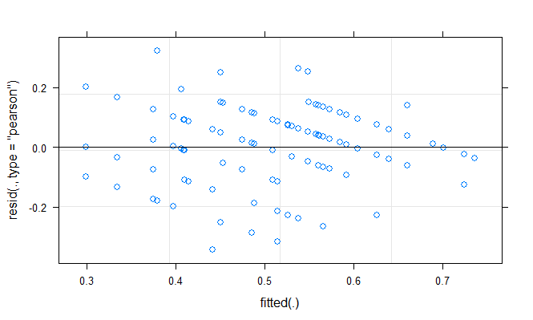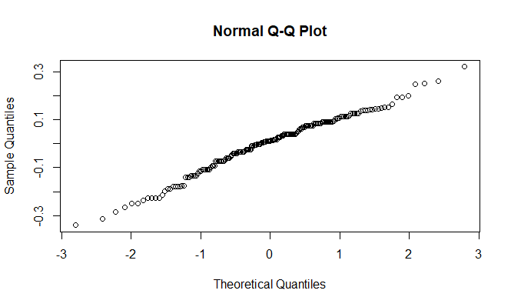

**CALI ONLY**

|  |  |  |  |  |  |  |  |
| --- | --- | --- | --- | --- | --- | --- | --- |
|  | **(Intercept)** | **period** | **df** | **logLik** | **AICc** | **delta** | **weight** |
|  |  |  |  |  |  |  |  |
| **2** | 0.4406 | + | 5 | 114.9 | -219.4 | 0.000 | 0.90702 |
| **1** | 0.4176 | *NA* | 4 | 111.5 | -214.9 | 4.556 | 0.09298 |

Linear mixed model fit by maximum likelihood . t-tests use Satterthwaite's method ['lmerModLmerTest']

Formula: mix_idx ~ period + (1 | am_pm) + (1 | email)

Data: clo

AIC BIC logLik deviance df.resid

-219.8 -203.8 114.9 -229.8 176

Scaled residuals:

Min 1Q Median 3Q Max

-2.588 -0.568 0.004 0.458 3.228

Random effects:

Groups Name Variance Std.Dev.

email (Intercept) 0.01162 0.1078

am_pm (Intercept) 0.00654 0.0809

Residual 0.01423 0.1193

Number of obs: 181, groups: email, 7; am_pm, 2

Fixed effects:

Estimate Std. Error df t value Pr(>|t|)

(Intercept) 0.4406 0.0714 3.8310 6.17 0.0040 **

periodP2 -0.0481 0.0184 173.9951 -2.61 0.0099 **

---

Signif. codes: 0 ‘***’ 0.001 ‘**’ 0.01 ‘*’ 0.05 ‘.’ 0.1 ‘ ’ 1

Correlation of Fixed Effects:

(Intr)

periodP2 -0.124

confidence intervals

2.5 % 97.5 %

.sig01 0.06516 0.21125

.sig02 0.03535 0.34979

.sigma 0.10775 0.13307

(Intercept) 0.23094 0.64945

periodP2 -0.08439 -0.01174

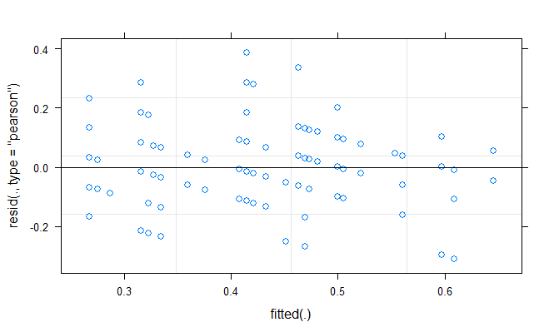

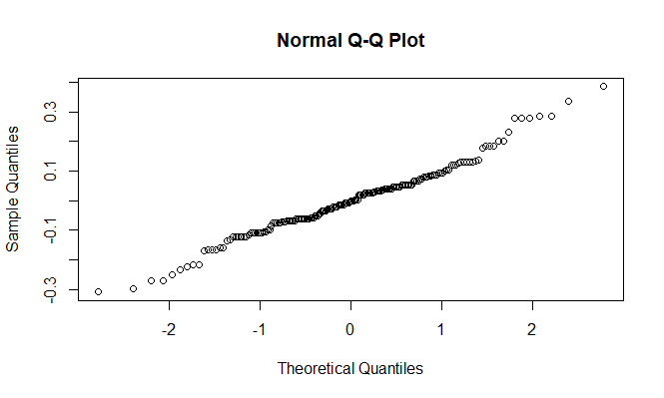

**OTHER CITIES**

|  |  |  |  |  |  |  |  |
| --- | --- | --- | --- | --- | --- | --- | --- |
|  | **(Intercept)** | **period** | **df** | **logLik** | **AICc** | **delta** | **weight** |
|  |  |  |  |  |  |  |  |
| **2** | 0.515 | + | 5 | 547.1 | -1084 | 0.000 | 0.9122 |
| **1** | 0.505 | *NA* | 4 | 543.7 | -1079 | 4.682 | 0.0878 |

Linear mixed model fit by maximum likelihood . t-tests use Satterthwaite's method ['lmerModLmerTest']

Formula: mix_idx ~ period + (1 | am_pm) + (1 | email)

Data: other

AIC BIC logLik deviance df.resid

-1084.1 -1060.6 547.1 -1094.1 821

Scaled residuals:

Min 1Q Median 3Q Max

-2.6938 -0.6430 0.0593 0.7371 2.7635

Random effects:

Groups Name Variance Std.Dev.

email (Intercept) 0.00958 0.0979

am_pm (Intercept) 0.00236 0.0486

Residual 0.01417 0.1190

Number of obs: 826, groups: email, 24; am_pm, 2

Fixed effects:

Estimate Std. Error df t value Pr(>|t|)

(Intercept) 0.51498 0.04021 3.47391 12.81 0.00048 ***

periodP2 -0.02193 0.00845 804.27539 -2.59 0.00963 **

---

Signif. codes: 0 ‘***’ 0.001 ‘**’ 0.01 ‘*’ 0.05 ‘.’ 0.1 ‘ ’ 1

Correlation of Fixed Effects:

(Intr)

periodP2 -0.095

confidence intervals

2.5 % 97.5 %

.sig01 0.07394 0.135984

.sig02 0.02210 0.206677

.sigma 0.11345 0.125124

(Intercept) 0.39282 0.637119

periodP2 -0.03852 -0.005347

